# **Understanding the Project**

|  |  |
| --- | --- |
| Team Members: | * Jonathan Argumedo - jargumedo@miners.utep.edu * Cristian Molina - camolinasim@miners.utep.edu * Bryan Molina - bamolina4@miners.utep.edu * Diego Rivera - darivera2@miners.utep.edu * Will Palafox - wjpalafox@miners.utep.edu |
| Project name: | MSSwE Advising Management System |
| List Stakeholders (name and institution): | * Customers:   + Department of Computer Science Current and Prospective Students   + MSSwE Program Director * UTEP IT Department * Project Implementation Team |
| List the people working in the project and their roles | * MSSwE Program Director: Customer * UTEP IT Department:   + System Administrators: Access Management   + Enterprise Software Engineers: External Systems Configuration Management (Office 365, Goldmine) * Project Implementation Team   + Team leader: Jonathan Argumedo   + Customer Interface Manager: Cristian Molina   + Design Manager: Bryan Molina   + Planning manager: Diego Rivera   + Quality Manager: Will Palafox |
| Brief project description: | Our project aims to address 2 main problems which are:   1. The difficulties communicating with the students from the program director perspective. At the moment, the program director has a lot of difficulties running the student advising process because it requires a lot of information to be manually gathered. 2. Doing repetitive tasks to obtain student information that is already available on Goldmine.   We would take an iterative approach to start building a modular system that will address these problems by enforcing a defined workflow that will require less involvement from both the program director and the students. This will be achieved by pre-loading relevant information for the advising process and delivering the information in a user-friendly form that will provide all the relevant information for the students and the program director. |
| List all the subsystems, modules or components of your system | * MSSwE Advising Management System   + Appointment Management Module: This component will interface with the Office 365 calendar and email to manage meetings scheduled for advising.   + Form Workflow Module: The objective of this component is to enforce the business rules of the advising process. For example, requiring students to provide necessary information before making an appointment as well as providing the students the information they need to select/change/update their schedule.   + Course Schedule Validation: This module will interface with Goldmine to get the available courses for the advising term and will check that none of the available courses will conflict with courses already enrolled or past courses.   + User Authentication Module: This module will verify the user credentials against the school active directory via an API. We are currently assuming this can be done through Office 365 Azure AD.   + Degree Plan Validation Module: This module will oversee interfacing with Goldmine to extract the degree plan information for the student and will provide that info to the program director as well.   + Course Suggestion Module: This module will compare the required courses against the already filtered available courses, to provide the students a list of the courses they can or should enroll in. Courses already enrolled in will not be available to be added again for the same semester. |
| What Software Engineering concepts will be applied, specially list those related to requirements engineering: | **Abstraction**: The MSSwE Advising Management System abstracts the following modules from the students, program director, goldmine and Office 365:   * Appointment Management Module * Form Workflow Module * Course Schedule Validation * User Authentication * Course Suggestion Module * Degree Plan Evaluation Module.   To all actors, it looks as if they were talking to the same object. However, they are talking to a combination of many smaller modules, and that's abstraction.  **Modularization:** Each component of the MSSwE Advising Management System to divide the functionality of the system into multiple discrete and independent modules capable of carrying out tasks independently. If we wanted to make a change on how the system identifies users, we would only need to change the codebase inside the User Authentication module.  **Separation of concerns:** Each component of the system is responsible for a specific concern. For example, all the logic from user authentication goes into the user authentication module, and all the logic for appointment management goes into the appointment management module. Each module addresses a separate concern.  **Whole/parts**: The whole is the MSSwE Advising Management System because it aggregates several smaller modules and provides services built from combinations of those modules. The parts are every module contained within the MSSwE Advising Management System. Each part provides some functionality to the whole. |

# Context Diagram Level 1

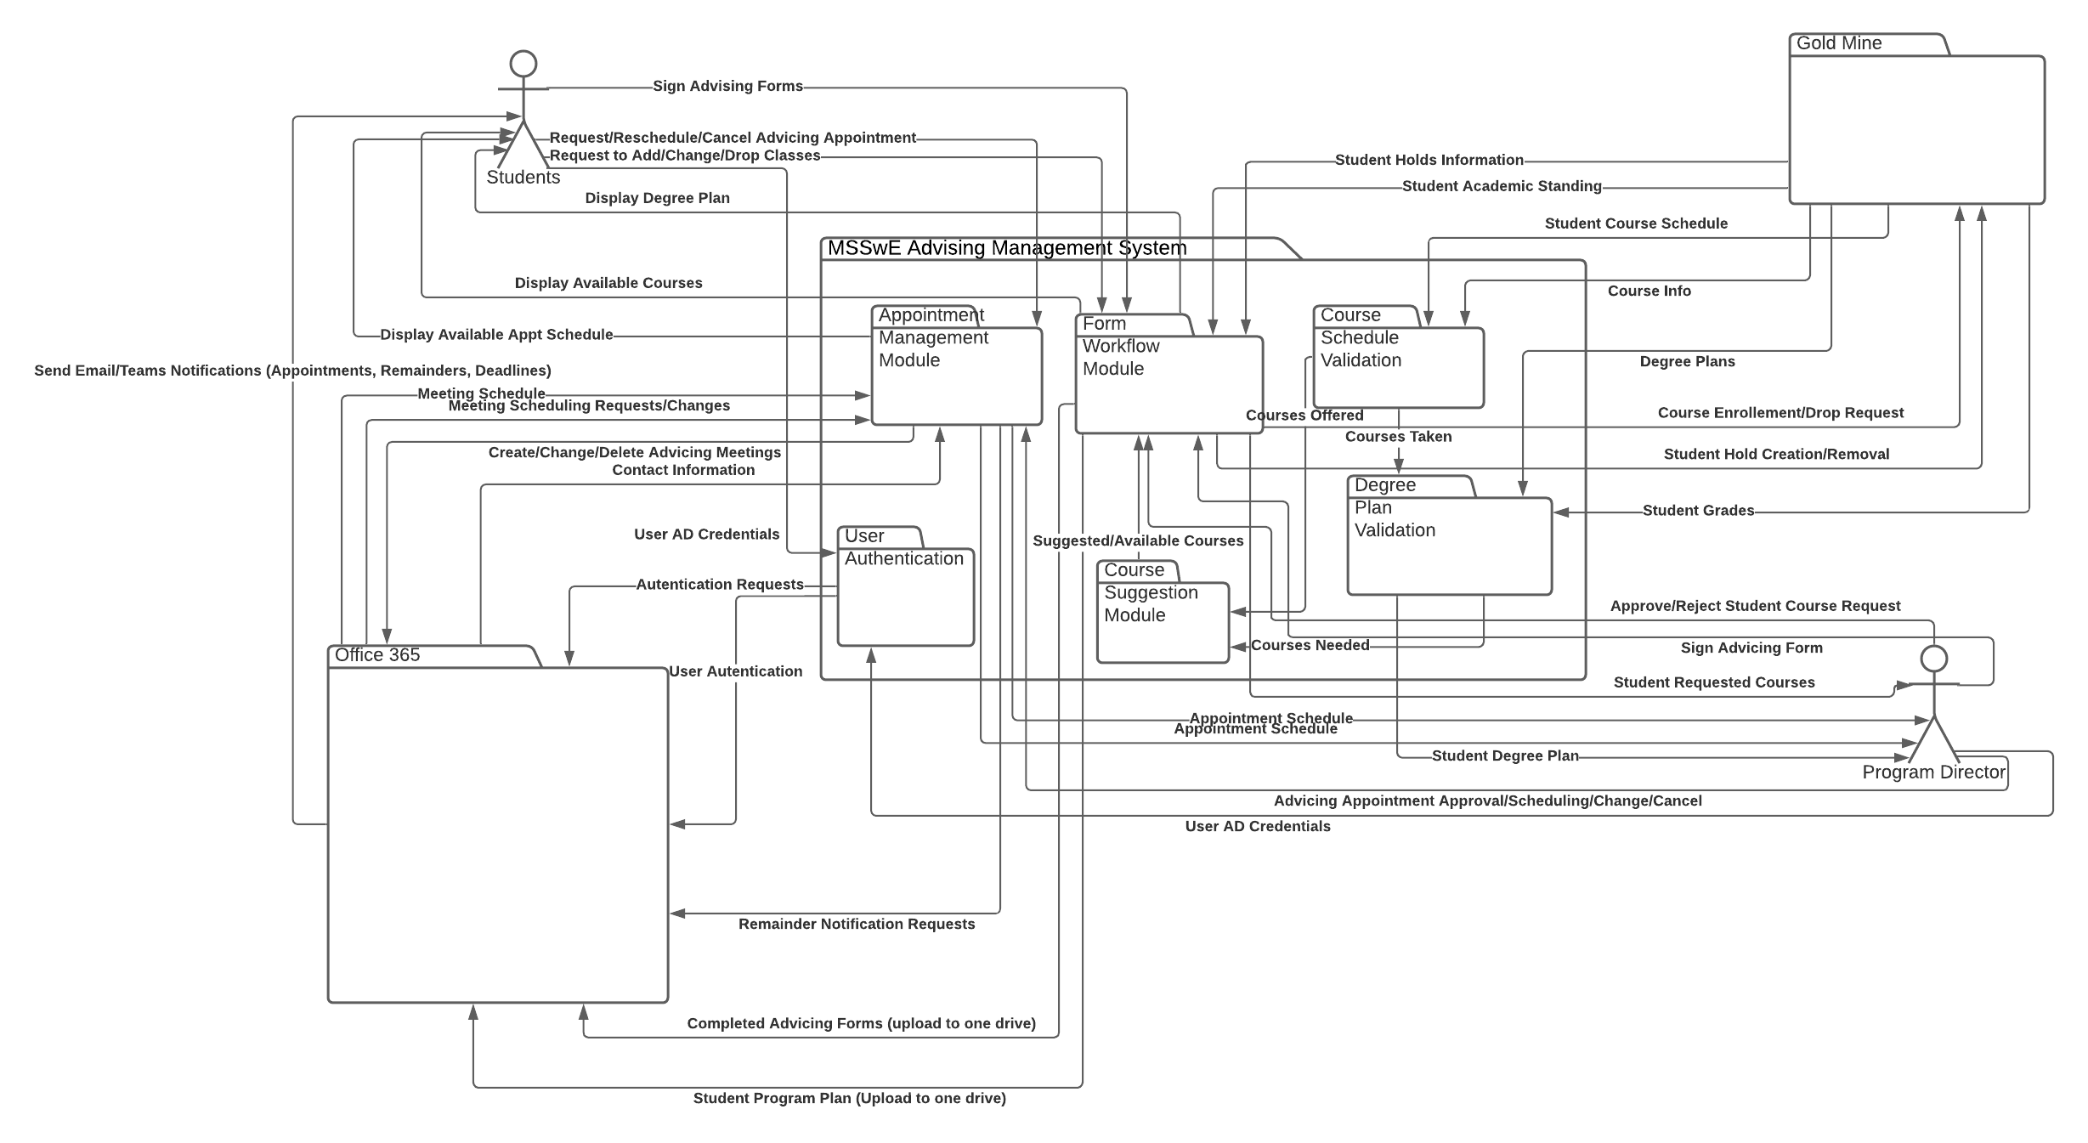

Lucid Chart Link: <https://lucid.app/lucidchart/invitations/accept/87331683-429f-47dc-95c2-ff6f3d605f9e>